**Filling Machine from Mathew:**

Internal wiring diagram (x6 inside machine):

Parts:

6x Pump (insert part #)

12x Hoses

6x Motor Controller CCM5N4

3x Relay YJ2N-GS

6x 10kΩ Potentiometer on Front Panel

6x On/Off Switch on Front Panel

1x 24V Power Supply

1x Power Cord Input

1x Control Unit (Part of Front Panel)

1x Foot Petal Switch

Pictures of filling machine from Matthew:

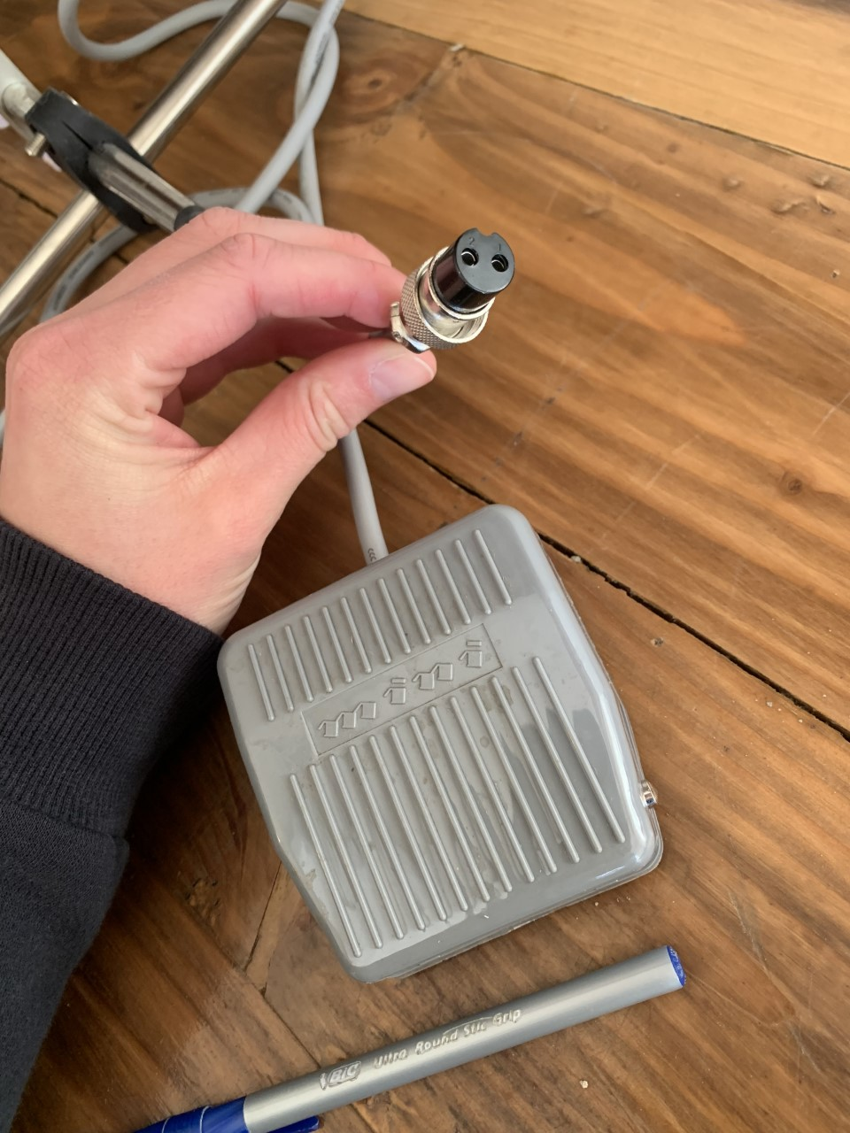

Figure 1: The foot pedal used to power?

Figure 2: The clamp that holds the tubes in place for the wine to come out and fill up to 6 pouches separatelyA picture containing text, indoor, floor, cluttered

Description automatically generated

Figure 3: Inside the machineA picture containing engine

Description automatically generated

Figure 4: CLose-up of the circuit boardsA picture containing diagram

Description automatically generated

Figure 5: Close up of the power supply(black box) and potentiometers (gold knobs) A picture containing connector

Description automatically generated

Figure 6: Close-up of a set of pumps with specs on side

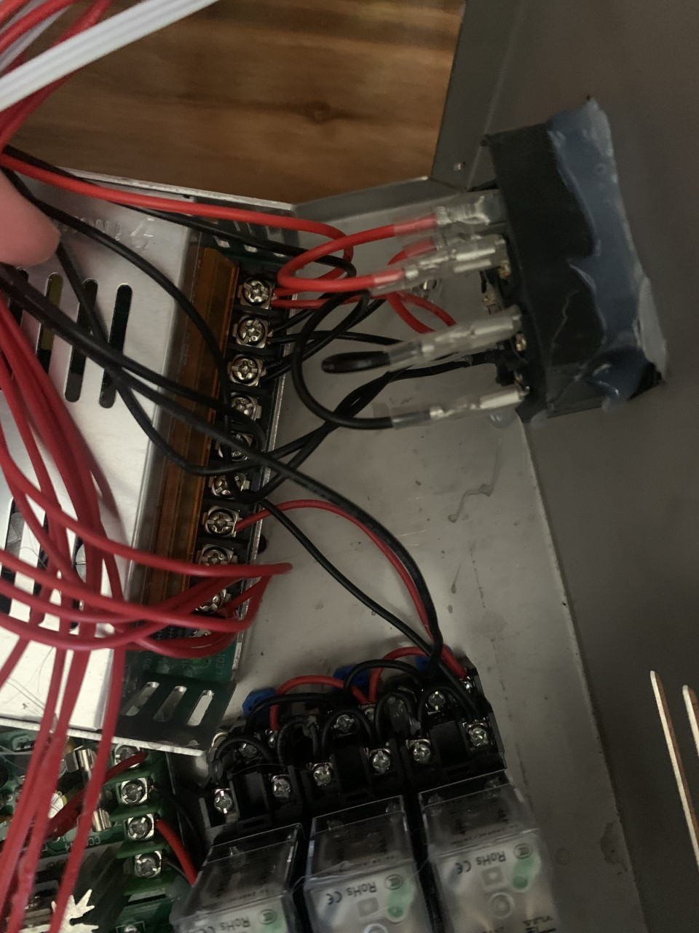

Figure : Close-up of wiring

Figure : Component Specs